CASA of Southeastern Illinois Fall Fundraiser

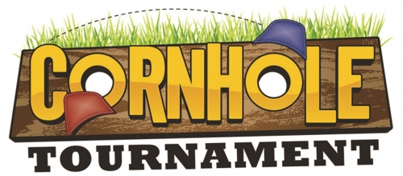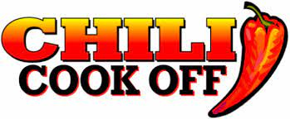
$50 Per Team $20 Per Entry

October 21st Starts at Noon
Oasis Bar and Grill Ridgway

Join us for Lunch Chili and BBQ $10 per person

Cornhole Winners
1st Place $100
2nd Place $75
3rd Place $50
Chili Winner
$50
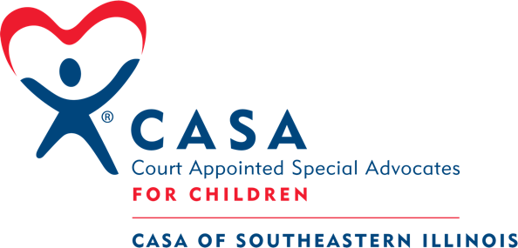
CASA of Southeastern Fall Fundraiser
Sponsorships

October 21st Oasis Bar and Grill
Starts at Noon

Sponsorship levels
$100 Sign Sponsor –Sign at the Event
$250 Corporate Sponsor – Sign at Event, Cornhole Team Entry
$500 Event Sponsor – Banner at event, Corn Team Entry, 2 Meal Tickets
All levels receive advertisement on Facebook
